

Hospital Management System using SQL Project

* Balashanmugam



Table of Content:

1.Objective

2.Data Description

3.ER Diagram

4.Advanced SQL Queries

5.Conclusions



Objective:

- Analyse hospital data using SQL

- Track patient history and billing

- Generate appointment and diagnosis reports

- Identify high-performing doctors and resource use



Dataset Descriptions –

**Name:** Hospital Management System Dataset  
 **Number of Tables:** 5

| **Table Name** | **Description** |
| --- | --- |
| patients | Stores patient information like ID, name, age, gender, and contact number. |
| doctors | Contains doctor details such as ID, name, specialty, and contact info. |
| appointments | Records appointment details including date, patient ID, and doctor ID. |
| diagnoses | Maintains diagnosis records for patients with diagnosis description and date. |
| bills | Tracks billing data for each patient including amount and billing date. |



**ER Diagram:**

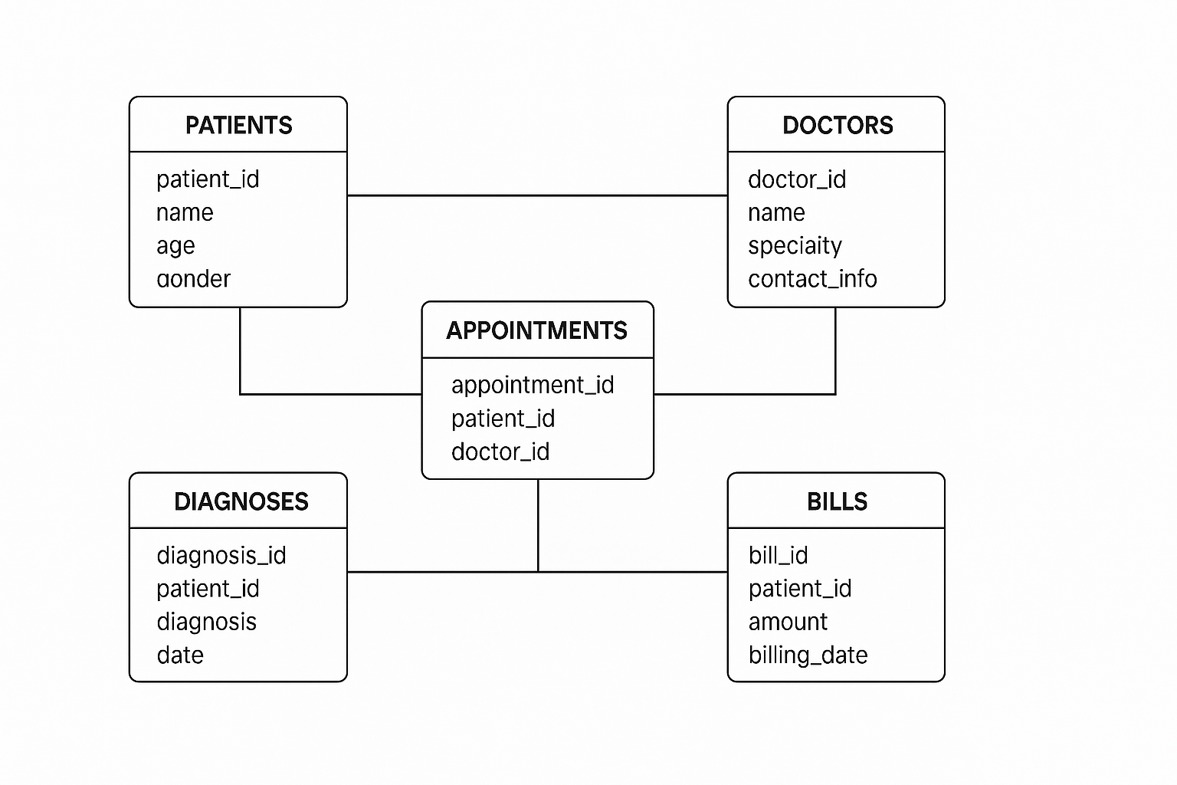



**Query 1**: Top 3 Doctors with Most Appointments

**SELECT d.name, COUNT(*) AS**

**total_appointments**

**FROM doctors d**

**JOIN appointments a ON d.doctor_id =**

**a.doctor_id**

**GROUP BY d.name**

**ORDER BY total_appointments DESC LIMIT 3;**

Sample Output:

Dr. Shah | 35

Dr. Khan | 29

Dr. Meera | 27



**Query 2**: Patients with Above-Average Billing

**SELECT p.name, SUM(b.amount) AS total_spent**

**FROM patients p**

**JOIN bills b ON p.patient_id = b.patient_id**

**GROUP BY p.name**

**HAVING SUM(b.amount) > (**

**SELECT AVG(total_amt) FROM ( SELECT SUM(amount)**

**AS total_amt FROM bills GROUP BY patient_id )**

**AS sub);**

Sample Output:

Arun K | 8500

Meena S | 7900



**Query 3**: Latest Diagnosis Per Patient

**SELECT name, description**

**FROM ( SELECT p.name, d.description, d.diagnosis_date,**

**ROW_NUMBER() OVER (PARTITION BY p.patient_id ORDER BY**

**d.diagnosis_date DESC) AS rn**

**FROM patients p JOIN diagnoses d ON p.patient_id =**

**d.patient_id )**

**AS sub WHERE rn = 1;**

Sample Output:

Kumar | Fever

Latha | Asthm



**Query 4**: Most Common Diagnoses

**SELECT description, COUNT(*)**

**AS freq FROM diagnoses**

**GROUP BY description**

**ORDER BY freq DESC LIMIT 5;**

Sample Output:

Cold | 40

Fever | 38

Diabetes | 33



**Query 5**: Monthly Appointment Trend

**SELECT DATE_FORMAT(appointment_date,**

**'%Y-%m') AS month, COUNT(*)**

**AS total FROM appointments**

**GROUP BY month**

**ORDER BY month;**

Sample Output:

2024-01 | 120

2024-02 | 140



**Query 6**: Highest Billed Patients

**SELECT p.name, MAX(b.amount)**

**AS highest_bill**

**FROM patients p JOIN bills b ON**

**p.patient_id = b.patient_id**

**GROUP BY p.name**

**ORDER BY highest_bill DESC LIMIT 5;**

Sample Output:

Shalini R | 5000

Vikram A | 4800



**Query 7**: Doctors with Multiple Specialties

**SELECT name, COUNT(DISTINCT**

**specialty) AS specialties**

**FROM doctors**

**GROUP BY name**

**HAVING COUNT(DISTINCT specialty) > 1;**

Sample Output:

Dr. Ravi | 2



**Query 8**: Patients Without Appointments

**SELECT name**

**FROM patients**

**WHERE patient_id NOT IN (SELECT**

**patient_id FROM appointments);**

Sample Output:

Ganesh B

Jaya N



**Query 9**: Total Revenue Per Month

**SELECT DATE_FORMAT(billing_date,**

**'%Y-%m') AS month,**

**SUM(amount) AS revenue**

**FROM bills**

**GROUP BY month**

**ORDER BY month;**

Sample Output:

2024-01 | 30000

2024-02 | 36500



**Query 10**: Doctor-Patient Mapping

**SELECT d.name AS doctor, p.name AS**

**patient FROM doctors d JOIN**

**appointments a ON d.doctor_id =**

**a.doctor_id JOIN patients p ON**

**a.patient_id = p.patient_id**

**ORDER BY d.name;**

**Sample Output**:

Dr. Shah | Anita

Dr. Shah | Mahesh

Dr. Khan | Pooja



**Conclusion:**

* **The Hospital Management System using SQL streamlines patient, doctor, and billing management through efficient data handling and reporting. It enhances healthcare operations with accurate insights and relational consistency.**